Lucky(10.12.1.36)-GhostIA

Sarah Ferenczi

Enumeration

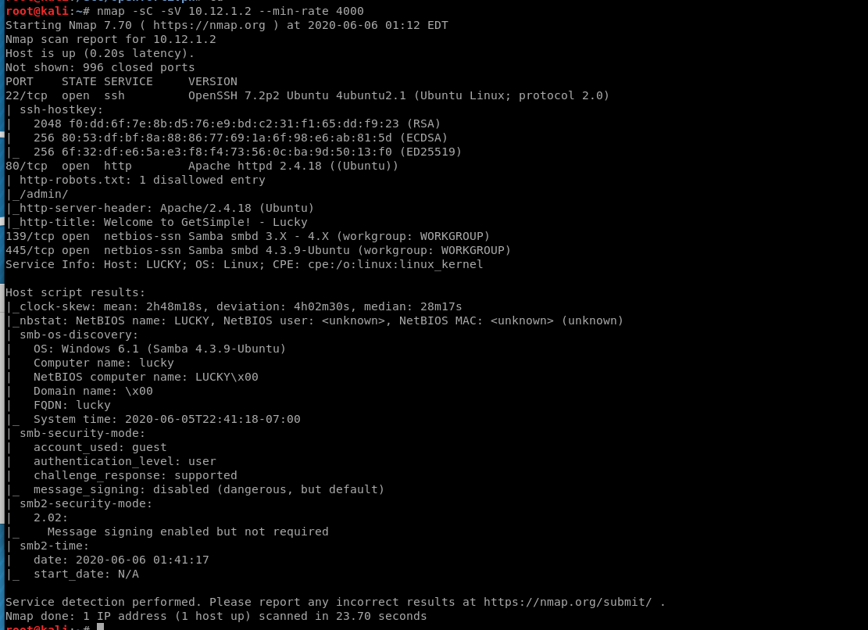

First, let’s do an nmap scan. Immediately we can notice Samba on this system.

Exploitation

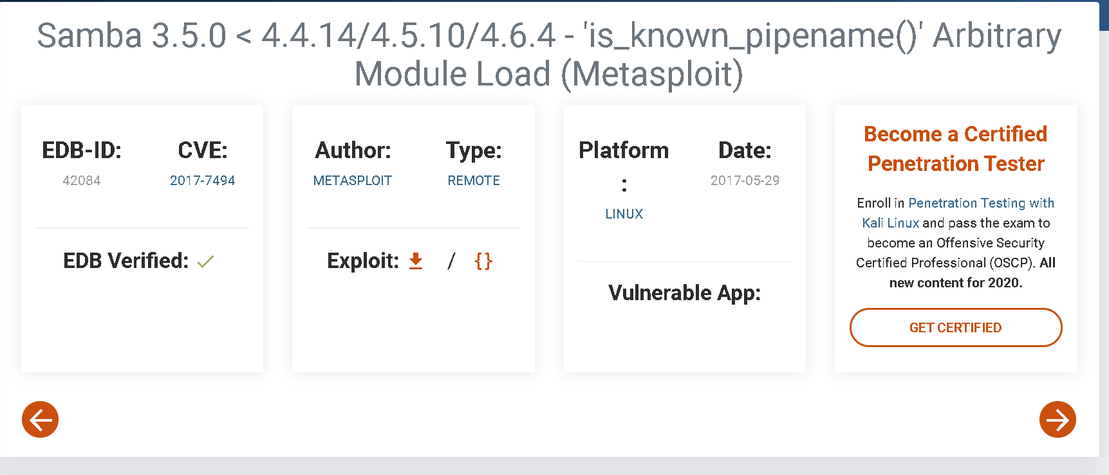

If you look up the version number of this version of Samba, we find an exploit with a metasploit module.

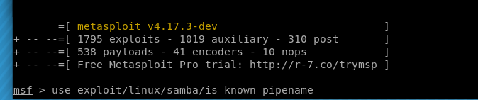

Let’s go ahead and use the exploit for this.

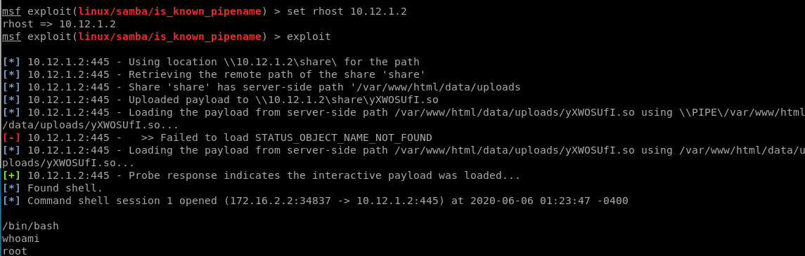

This instantly gives us root on the box.

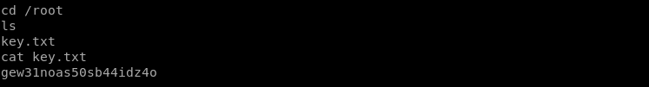

Let’s navigate to /root and get the key